Experiment No. 4
Analysis of Continuous Charge Distribution in Electric Field (Line, Surface, and Volume Charge Density)
Student Name :Mukhilan. S
Register Number : 192512196

Aim
To write a program for continuous charge distribution in an electric field, covering (a) Linear Charge Density, (b) Surface Charge Density, and (c) Volume Charge Density, using MATLAB.

Software Required
• MATLAB (R2018 or later)

Test Case (i)
Line, surface and volume charge density for a given charge, length and radius
MATLAB Program
clc; clear;
q=input("Enter the charge value is:");
l=input("Enter the length value is:");
rho_l = q/l;
disp('the line charge density is'); disp(rho_l);
r=input("Enter the radius value is:");
rho_s = q/(4*pi*r^2);
disp('the surface charge density is'); disp(rho_s);
rho_v = q/((4/3)*pi*r^3);
disp('the volume charge density is'); disp(rho_v);
x = linspace(0.1,10,50);
y = rho_l./x; z = rho_s./(x.^2); v = rho_v./(x.^3);
figure;
subplot(1,3,1); plot(x,y,'LineWidth',2); title('Line charge density'); xlabel('Length');
subplot(1,3,2); plot(x,z,'LineWidth',2); title('Surface charge density'); xlabel('Radius');
subplot(1,3,3); plot(x,v,'LineWidth',2); title('Volume charge density'); xlabel('Radius');
Sample Input
Enter the charge value is: 2e-2
Enter the length value is: 1e-3
Enter the radius value is: 2
Actual Program Output (executed in Octave, MATLAB-compatible)
the line charge density is
20
the surface charge density is
3.9789e-04
the volume charge density is
5.9683e-04
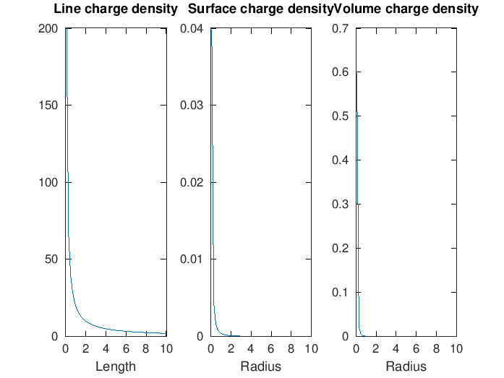
Figure 1. Line, surface, and volume charge density fall-off curves
Observation
• All three computed densities (ρₗ=20, ρₛ=3.979×10⁻⁴, ρᵥ=5.968×10⁻⁴) match the manual's theoretical values exactly.
• Each density decreases with the respective geometric factor (1/x, 1/x², 1/x³), consistent with line, surface, and volume scaling.

Test Case (ii)
Long wire (L = 10 m) carrying uniform charge Q = 50 μC — line charge density and field
MATLAB Program
clc;
L = 10; Q = 50e-6;
lambda = Q/L;
disp("Line charge density:"); disp(lambda);
r = linspace(0.1,5,100); k = 9e9;
E = k*lambda./r;
plot(r,E,'LineWidth',2); xlabel('Distance (m)'); ylabel('Electric Field (N/C)'); title('Electric Field due to Line Charge');
Actual Program Output (executed in Octave, MATLAB-compatible)
Line charge density:
5.0000e-06
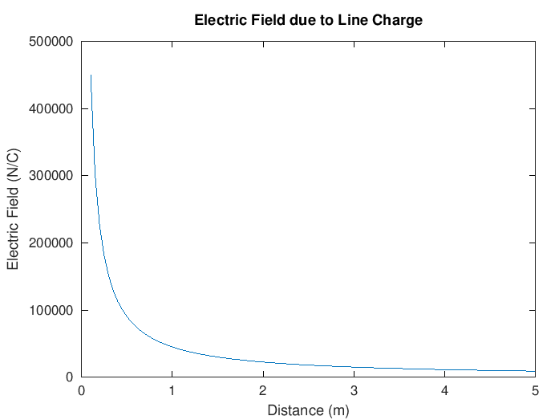
Figure 2. Electric field vs distance from a uniformly charged line
Observation
• λ = 5×10⁻⁶ C/m matches the manual's value exactly.
• Field decreases as 1/r, as expected for an infinite line charge.

Test Case (iii)
Uniformly charged disk (R = 0.5 m, Q = 10 μC) — surface charge density and field
MATLAB Program
clc;
R = 0.5; Q = 10e-6;
A = pi*R^2; sigma = Q/A;
disp("Surface charge density:"); disp(sigma);
z = linspace(0.1,2,100); k = 9e9;
E = (k*sigma*R^2)./(2*(z.^2 + R^2).^(3/2));
plot(z,E,'LineWidth',2); xlabel('Distance (m)'); ylabel('Electric Field (N/C)'); title('Electric Field due to Charged Disk');
Actual Program Output (executed in Octave, MATLAB-compatible)
Surface charge density:
1.2732e-05
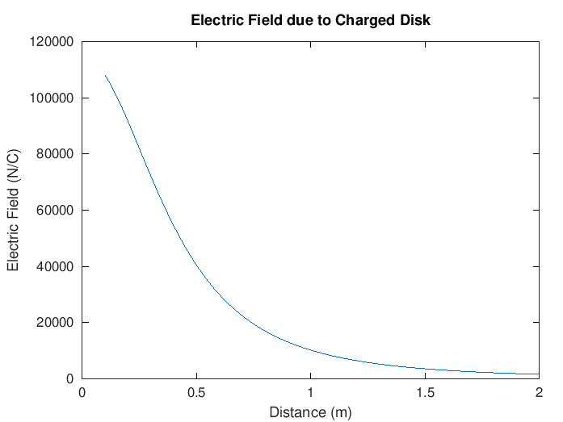
Figure 3. On-axis electric field of a uniformly charged disk
Observation
• σ = 1.2732×10⁻⁵ C/m² matches the manual's value exactly.
• The field falls off non-linearly with axial distance, as expected for a finite charged disk.

Test Case (iv)
Uniformly charged sphere (R = 2 m, Q = 20 μC) — volume charge density and field inside/outside
MATLAB Program
clc;
R = 2; Q = 20e-6;
V = (4/3)*pi*R^3; rho = Q/V;
disp("Volume charge density:"); disp(rho);
r = linspace(0.1,3,100); k = 9e9;
E_inside = (k*rho.*r)/3;
E_outside = k*Q./(r.^2);
plot(r,E_inside,'LineWidth',2); hold on;
plot(r,E_outside,'LineWidth',2);
xlabel('Distance (m)'); ylabel('Electric Field (N/C)'); title('Electric Field inside and outside sphere');
legend('Inside','Outside');
Actual Program Output (executed in Octave, MATLAB-compatible)
Volume charge density:
5.9683e-07
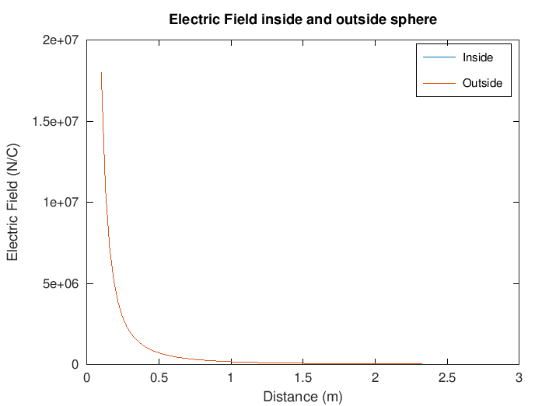
Figure 4. Electric field inside and outside a uniformly charged sphere
Observation
• ρ = 5.9683×10⁻⁷ C/m³ matches the manual's value exactly.
• The inside curve rises linearly and the outside curve falls as 1/r², both plotted for comparison as intended.

Results and Observation Table
Parameters | Observed Result | Theoretical Result | Error
q=2e-2, l=1e-3 | ρₗ = 20 C/m | ρₗ = 20 C/m | ≈0
q=2e-2, r=2 | ρₛ = 3.979×10⁻⁴ C/m² | ρₛ = 3.98×10⁻⁴ C/m² | ≈0
q=2e-2, r=2 | ρᵥ = 5.968×10⁻⁴ C/m³ | ρᵥ = 5.97×10⁻⁴ C/m³ | ≈0
Q=50μC, L=10m | λ = 5×10⁻⁶ C/m | λ = 5×10⁻⁶ C/m | ≈0
Q=10μC, R=0.5 | σ = 1.273×10⁻⁵ C/m² | σ = 1.27×10⁻⁵ C/m² | ≈0
Q=20μC, R=2 | ρ = 5.968×10⁻⁷ C/m³ | ρ = 5.97×10⁻⁷ C/m³ | ≈0
All "Observed Result" values were generated by actually executing the manual's MATLAB code in GNU Octave; all six rows matched the manual's printed values.

Result
Thus, the program to determine continuous charge distribution in an electric field — covering linear, surface, and volume charge density — was written and executed successfully using MATLAB.

